Web Time Entry is the new time keeping method for student employees at City College of San Francisco. Students will be responsible for entering and submitting their hours worked every pay period. After a student has submitted his/her hours the student’s supervisor will be responsible for approving the hours worked. When the supervisor has approved the student’s hours student payroll will process the entries for payment.
Each day of the pay period when a student comes to work he/she will sign a time log for that day which shows the hour (within 15 minutes) when the student arrived at work and the hour (within 15 minutes) when he/she left work. When the student enters time for pay on Web Time Entry, he/she will need to key in the time in/time out for each day. When approving the Web Time Entry of each student, the supervisor should use the time log of the student to verify the hours that they approve for payroll.
It is solely the responsibility of the student to enter and maintain an accurate representation of his/her hours worked. If the student does not enter on the Web the correct hours worked by the published deadline for that pay period, the hours will NOT be processed by Student Payroll during that pay period. The hours will be paid in the subsequent pay period thereby causing the student’s paycheck to be delayed by an additional two weeks!

- Instructions
  - Start Microsoft Internet Explorer on your PC.
  - Web Time Entry will work best with version 6.0 or higher.
  - To verify your version number:
a. Click on ‘Help’
b. Click on ‘About Internet Explorer
  - In your browser select the Smallest Text Size (View->Text Size->Smallest) to view the entire screen at one time.
  - While entering time in the Web Time Entry system, use Navigation Buttons included within the web page to navigate during time entry.
  - DO NOT use the browser Back/Forward buttons (doing so may lead to unpredictable results)!
B. Logging On
1. Log onto Banner Web
a. Go to WWW.CCSF.EDU
b. Select ‘Administration’
c. Select ‘Payroll’ from the left column
d. Select ‘Ram Pay’
e. Select ‘Web Time Entry’
2. Scroll down to USERID and PIN
a. Enter USERID (Employee/Student ID)
b. Enter PIN (Personal Identification Number)

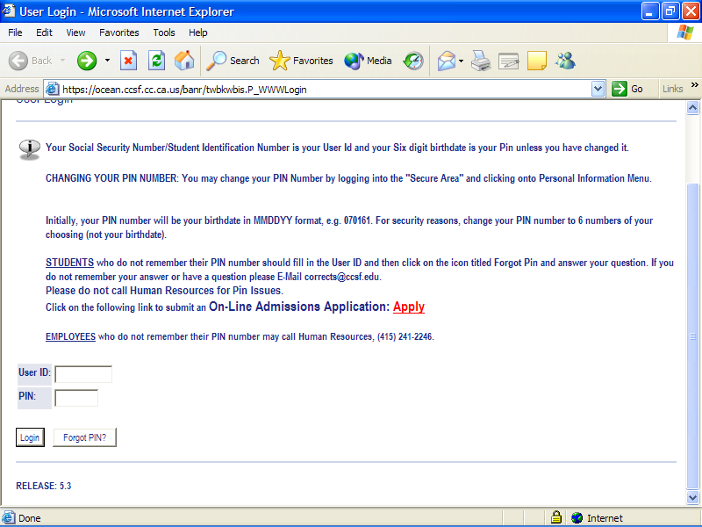
c. Press LOGIN and a new page appears with three options.
d. Verify your name and student ID near the top of the page.
e. Select EMPLOYEE SERVICES.
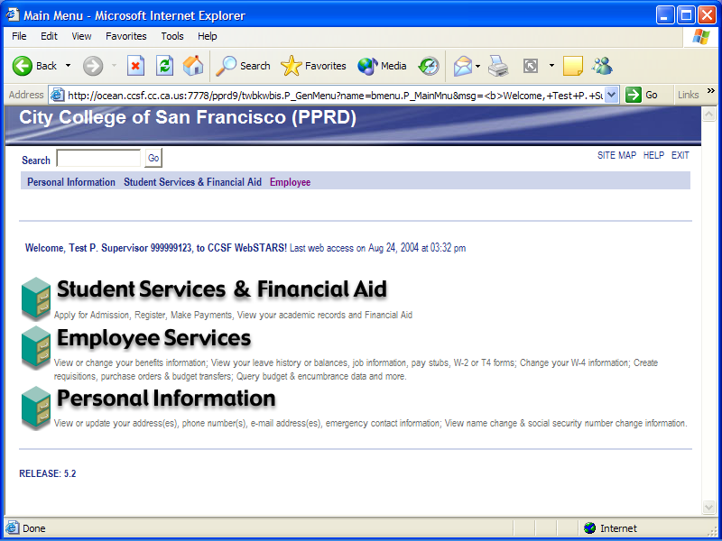
Verify this is your name after login.
Select:
Employee Services to
Continue.
f. The Employee Services page appears. Click on Time Sheet
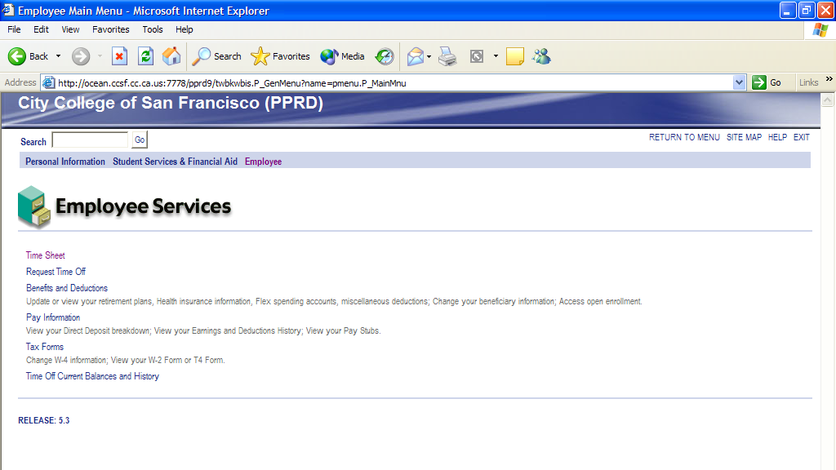
Select:
Time Sheet
to continue

C. Select Approver Function
1. This Selection Criteria Page shows all functions available for Web Time Entry.
2. Choose the Approve Time Sheet function.
3. To approve you own employees time select Proxy for SELF.
4. To act as Proxy for co-worker select the ‘co-worker’ instead of ‘self’

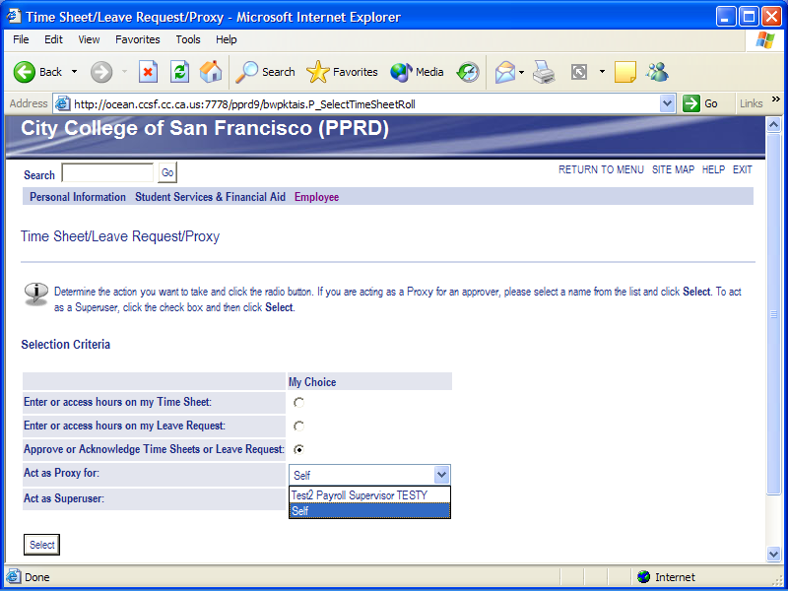
To approve your own employees time select Proxy for SELF.

To act as Proxy for co-worker select the ‘co-worker’ instead of ‘self’

D. Entering Time
1. This is the Time Sheet Page.
2. Click ‘NEXT/PREVIOUS’ button for more dates within the period.
3. Click the link under the date where you want to enter time.
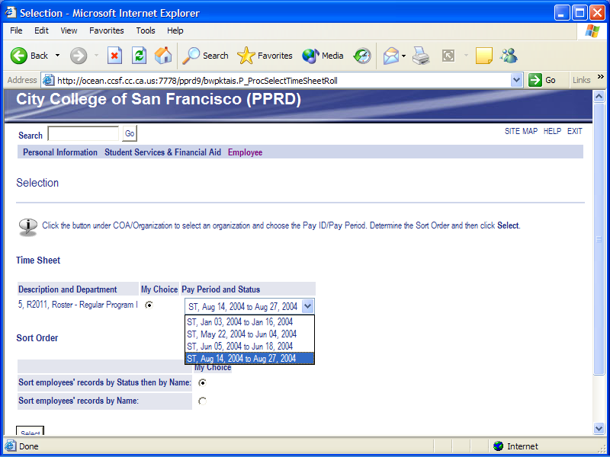
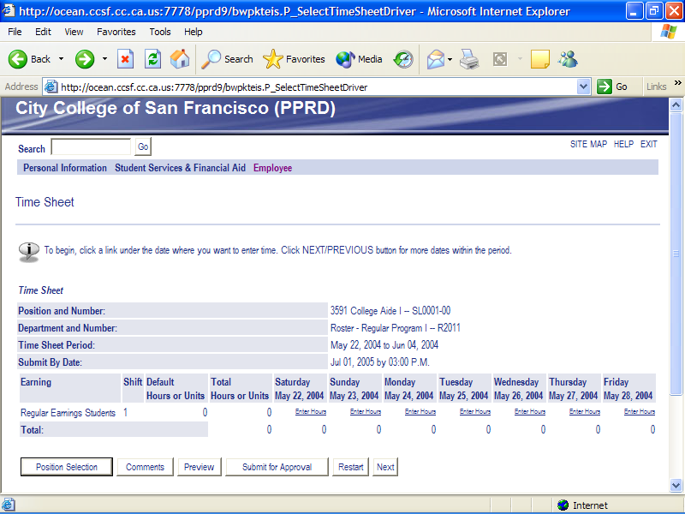
3. The Time In and Out Page will appear.
a. Time must be entered in Clock format (not military time).
(e.g. 8:30 AM or 11:30 PM
b. Time must be entered in 15 minute increments.
c. Time in and out must be entered only for actual hours worked.
d. The value of time-in must be earlier than the value for time-out.

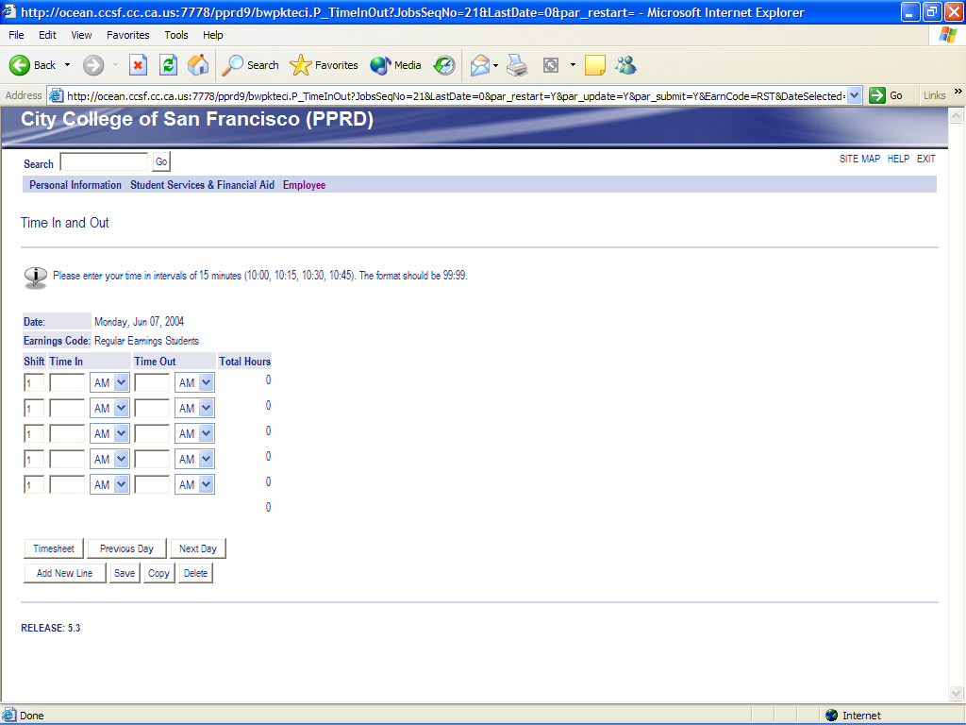

e. For hours that begin prior to 12:00 AM (Midnight) and end after 12:00 AM,
Time In and Out must be entered for two different days.
For Example: a student who comes to work at 11 PM and leaves at 2 AM
Day 1 Time IN: 11:00 PM Time OUT: 12:00 AM
Day 2 Time IN: 12:00 AM Time OUT: 02:00 AM
f. The following options are available for entry:
Next Day: This takes you to the next day for entry and will save the record that you just entered
Add New Line: This will add another entry line to the page. You may add as many ‘new lines’ as you need to report your hours worked.
- If you work the same hours from day to day, you can copy the hours that were entered for day 1 to day 2 instead of manually entering them for each day.
COPY HOURS:
  - Clicking on this button will take you to the Copy Page.
  - Use the criteria options on that page to indicate the days you want to copy time TO.
  - Do NOT select the day you are copying from.
  - If you select the original day the system will remove the hours from the originating day!

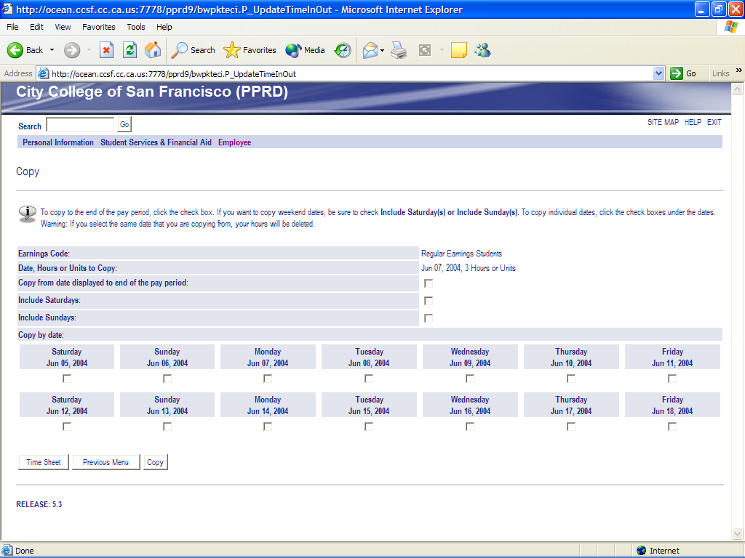
  - By selecting the Copy function, the hours in the originating day are saved.
  - Exit by clicking on the Time Sheet or Previous Menu buttons.
DELETE: This function will remove the entry from the day.
PREVIOUS MENU:
- Clicking this button will display the Time Sheet page.
- The hours entered on the Time In and Out page will be displayed in the summary area when you are returned to the previous menu.
- Always select ‘Previous Menu’ or ‘Time Sheet’ when all hours have been entered.
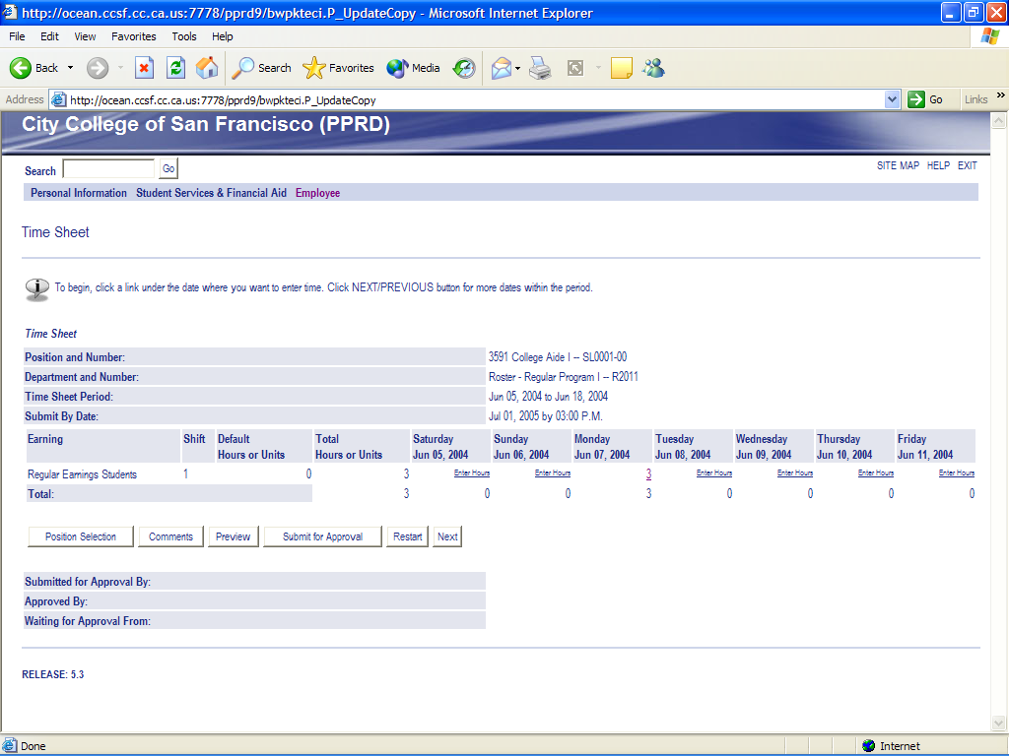
- Enter Comments:
  - Enter comments in order to account for any unusual situations related to your hours worked.
  - When you have completed entering any comments, press the Previous Menu button to save your entry and return to the Time Sheet page.
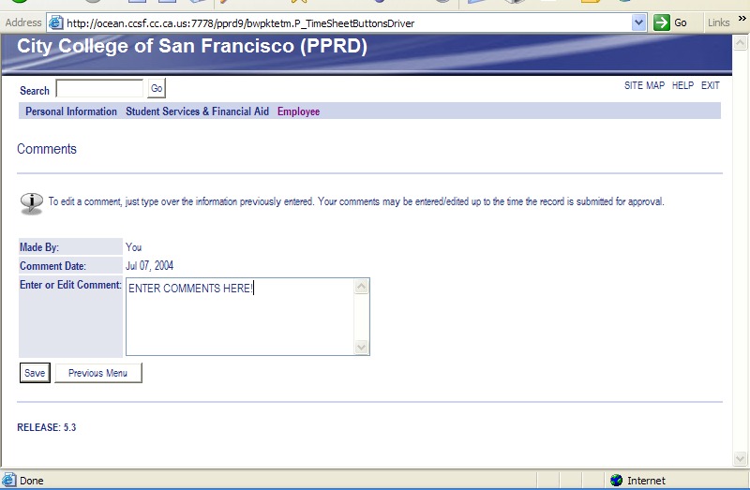
- Preview Time Sheet:
  - The ‘Preview’ page summarizes all of the information entered.
  - Print this page, using the browser print function, to get a paper copy to keep for your records.
  - Time Sheets will be kept on-line for 3 years.
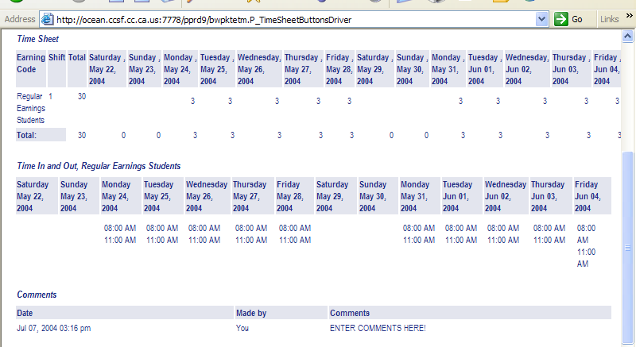
E. Submitting Time
1. Do NOT submit hours until Time Entry is complete for the entire pay period for this position.
2. Once YOU have submitted your hours , they cannot be changed.
3. You can exit without submitting time for approval. This will leave the record with an ‘In Progress’ status and it will not be submitted for approval or for payroll processing. You will have to return to Web Time Entry at a later date to finish your entry and to submit your time.
4. Click on the ‘Submit’ button to submit your time for approval by your supervisor.
5. After you submit your hours the record status will be changed to ‘Pending’ and your time sheet will be in the approval queue for your supervisor’s attention.
6. After your supervisor approves your time entry, your data will be sent to payroll processing.
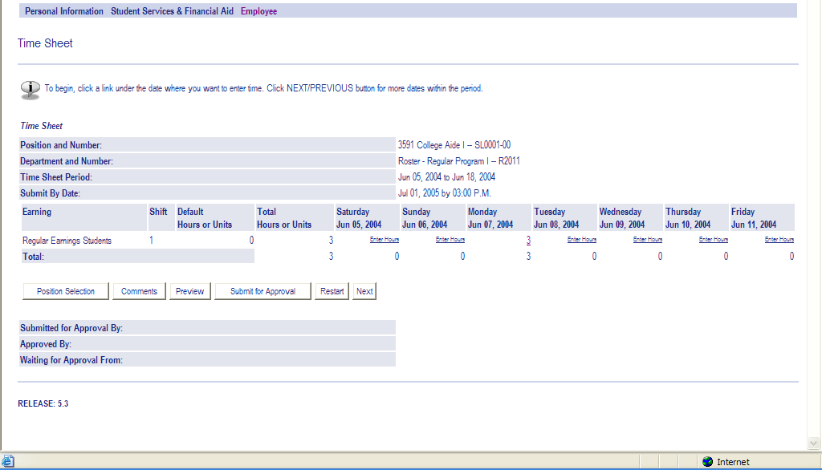
F. Certifying Time
1. By ‘certifying’ your entry, you are applying an electronic signature. This certifies that the hours that you entered are an accurate record of the hours that you actually worked. This electronic signature is required for purposes of auditing your entry.
2. To complete certification: Enter your PIN and click on OK.
3. The system will redisplay the Time Sheet page with the following message at the top of the page: Your time sheet was submitted successfully.

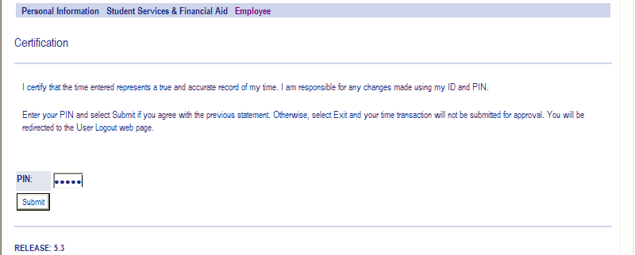
G. If you work for more than one department.
You will need to use the ‘Position Selection’ button’
1. This option takes you back to the Selection page.
2. Use this option if you work for more than one department or for more than one supervisor.
3. Return to section C this handbook and complete time entry for the new position.
H. Log Out
This will exit you from the Web Time Entry system.
1. Click the word EXIT in the upper right corner of the screen
2. For additional information contact the Student Payroll Office at Gough St
415-241-2368.

