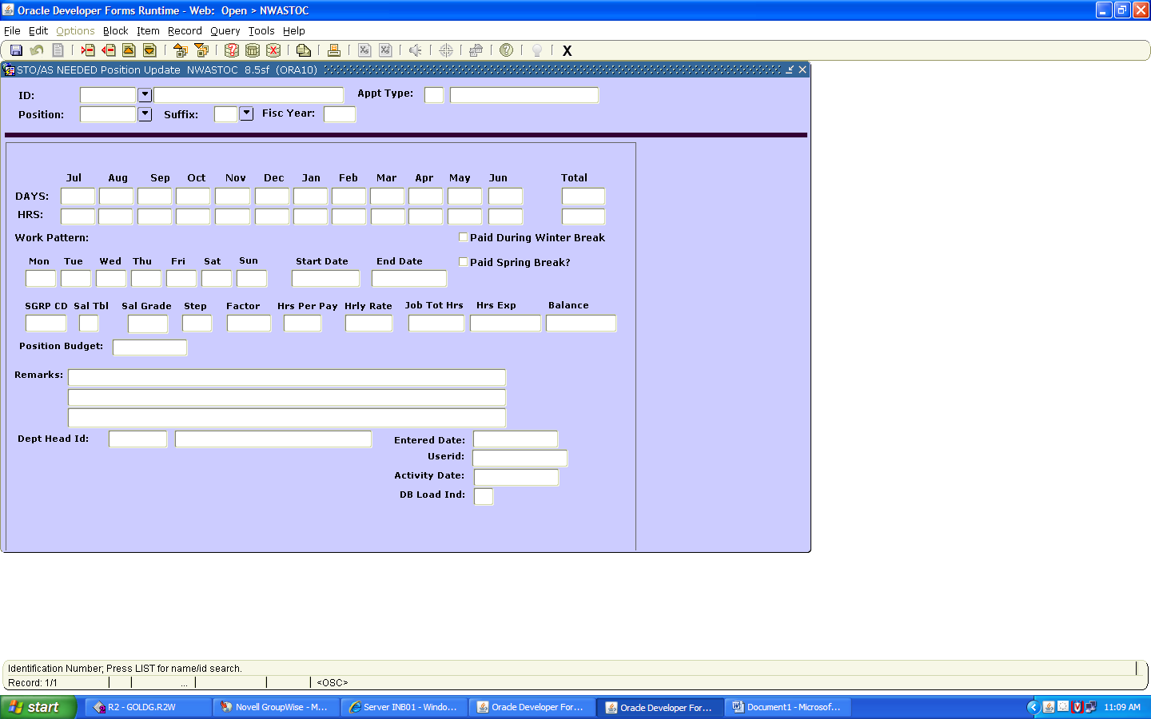
Effective for the school year of 2017-2018 the above Internet Native Banner (INB) form is to be used to rehire an STO employee. This form is to be used only to rehire an existing STO employee for the same number of hours that he/she was approved to work during the previous school year. If there is a new employee, a change in hours worked per school year or a change in funding a form 3 must be completed and submitted to Human Resources for processing.
During the school year 2017-2018, the STO employees will be paid as positive pay employees. Departments must enter time worked, and paid time off for the STO employee to be paid.

Please note that the instructions below correspond to the fields identified on the new STO rehire form. Types NWASTOC in Banner to go to the STO rehire form.
ID: Enter the STO rehire’s employee ID #. The name field will automatically populate. If the name field does not automatically populate, the ID number is wrong or the employee does not have a previous job record.
Appointment Type: This field will automatically populate.

Position: This field should automatically populate with the position from last year. You may override this automatic population by Select one of the positions from the drop down box.
Suffix: This field will automatically populate.
Fisc Year: Enter the correct fiscal year (ex: 2018)
Months: The 12 months of the fiscal year (auto populated)
Days: Enter the number of days per month that the STO employee will work. (ex: 5 for Jul 3 for Aug etc). The Total column will automatically populate. When you are finished the Total column will reflect the total number of days the employee is scheduled to be paid for the school term.
Hours: Enter the number of hours per month that the STO employee will work. (ex: 50 for Jul 30 for Aug etc). The Total column will automatically populate. When you are finished the Total column will reflect the total number of hours the employee is scheduled to be paid for the school term. The system will not allow you to enter more hours that the STO employee was scheduled to work in the previous school term.
Work Pattern: Enter the normal work week the STO employee is scheduled to work during her/his school term give a week with no exceptions (ex: holiday).
Start Date: Enter the date of the first day of the assignment. Date format should be DD-MMM-YYYY (ex: 01-JUL-2017).
End Date: Enter the date of the last day of the assignment. Date format should be DD-MMM-YYYY (ex: 30-JUN-2018).
Paid Dur Win Break: Check this box if the employee is scheduled to be paid for the four days between Christmas day and New Years Day. If this box is not checked, the department will not be able to enter PDS (paid days off-STO) for the STO employee to be paid. If the box is checked, all hours paid to the STO employee as PDS will count toward the maximum hours the STO employee may be paid for the school term.

Paid Dur Spr Break: Check this box if the employee is scheduled to be paid for the five days that are observed for spring break. If this box is not checked, the department will not be able to enter PDS (paid days off-STO) for the STO employee to be paid. If the box is checked, all hours paid to the STO employee as PDS will count toward the maximum hours the STO employee may be paid for the school term.
SGRP CD: Automatically populated from previous job assignment.

Sal TBL: Automatically populated from previous job assignment.
Sal GRDE: Automatically populated from previous job assignment.
Step: Automatically populated from previous job assignment.
Factor: Automatically populated from previous jobs assignment.
Hrs Per Pay: Automatically populated from previous job assignment.
Hrly Rate: Automatically populated from previous job assignment.
Job Ttl Hrs: Automatically populated from previous job assignment.
Hrs Exp: This field is an informational field. It identifies how many hours to date the STO employee has worked during the school term.
Balance: This field is an informational field. It identifies how many hours to date the STO employee has remaining during the school term.
Position Budget: This field is an informational field. It identifies the budget allocation for this position.
Remarks: This field can be used by the hiring department to enter information only data.
Dept Head ID: This is a required field. The department authorizers employee ID should be entered.
Entered Date: Automatically populated system date stamped with date the job was extended
UserID: This is a required field. The processing employee’s ID should be entered.
Activity Date: Automatically populated system date stamped with date the job was extended
DB Load Ind: This field is an informational field. If the field reads “Y” this verifies the process has been completed and is updating Banner based upon the information submitted. Once this field has a “Y” indicator no fields can be changed by the department. If a change is necessary, contact the payroll department for further instruction,

The STO employee will appear on the Departmental Time Entry roster in the period that contains the begin date.
The department time processor must enter (positive time) all time worked, and all leave to be paid. Worked time and paid leave time not entered will not be paid.

The authorizer has a responsibility to ensure that the time worked and leave time paid is properly documented and consistent with departmental time logs prior to authorizing these transactions.

