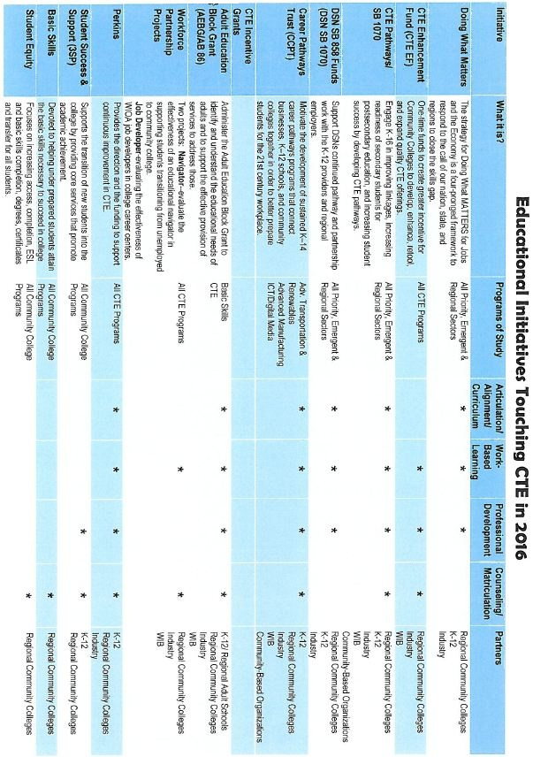

RESOURCE LIST
prepared for the CCSF CTE Steering Committee; May 5, 2016

- California Community Colleges Chancellor’s Office of Economic and Workforce Development
  - http://doingwhatmatters.cccco.edu/
- Strong Workforce Task Force Recommendations, November 2015
  - http://doingwhatmatters.cccco.edu/StrongWorkforce/ReportRecommendations.aspx
  - Handout: 25 recommendations
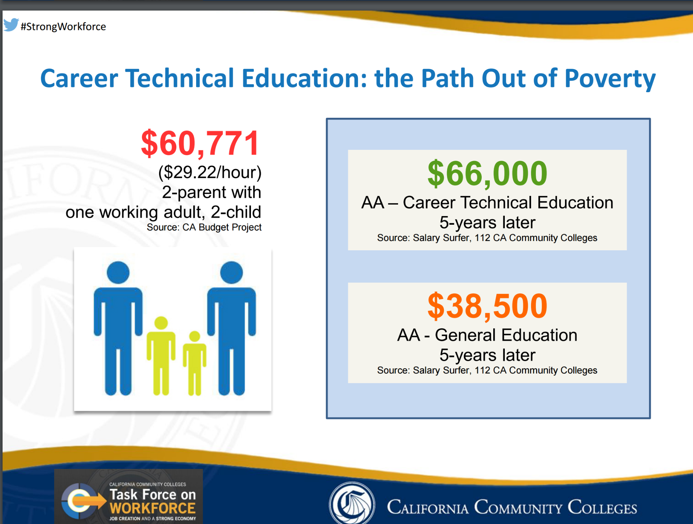
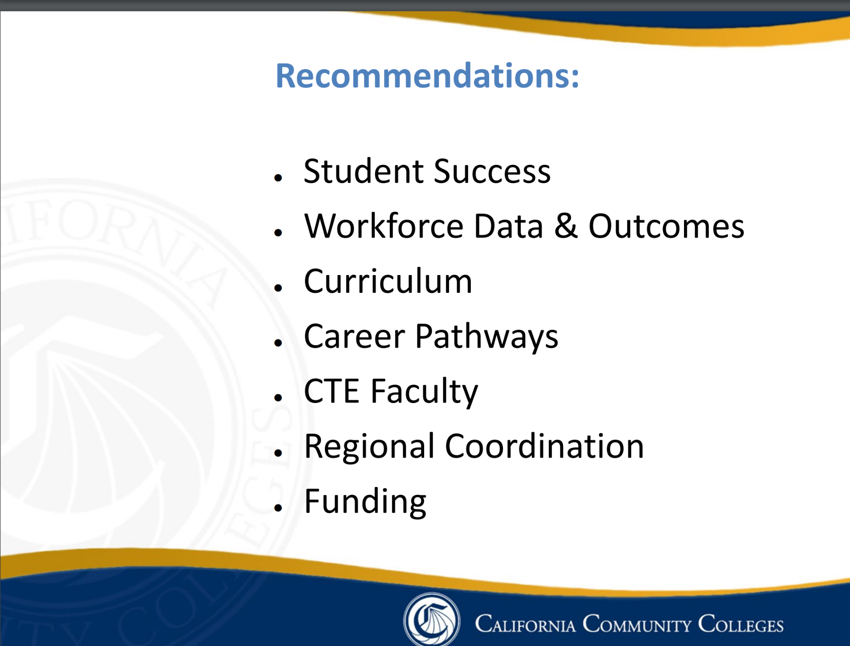

- CCC Scorecard – new Skills Builder feature
  - http://scorecard.cccco.edu/scorecard.aspx

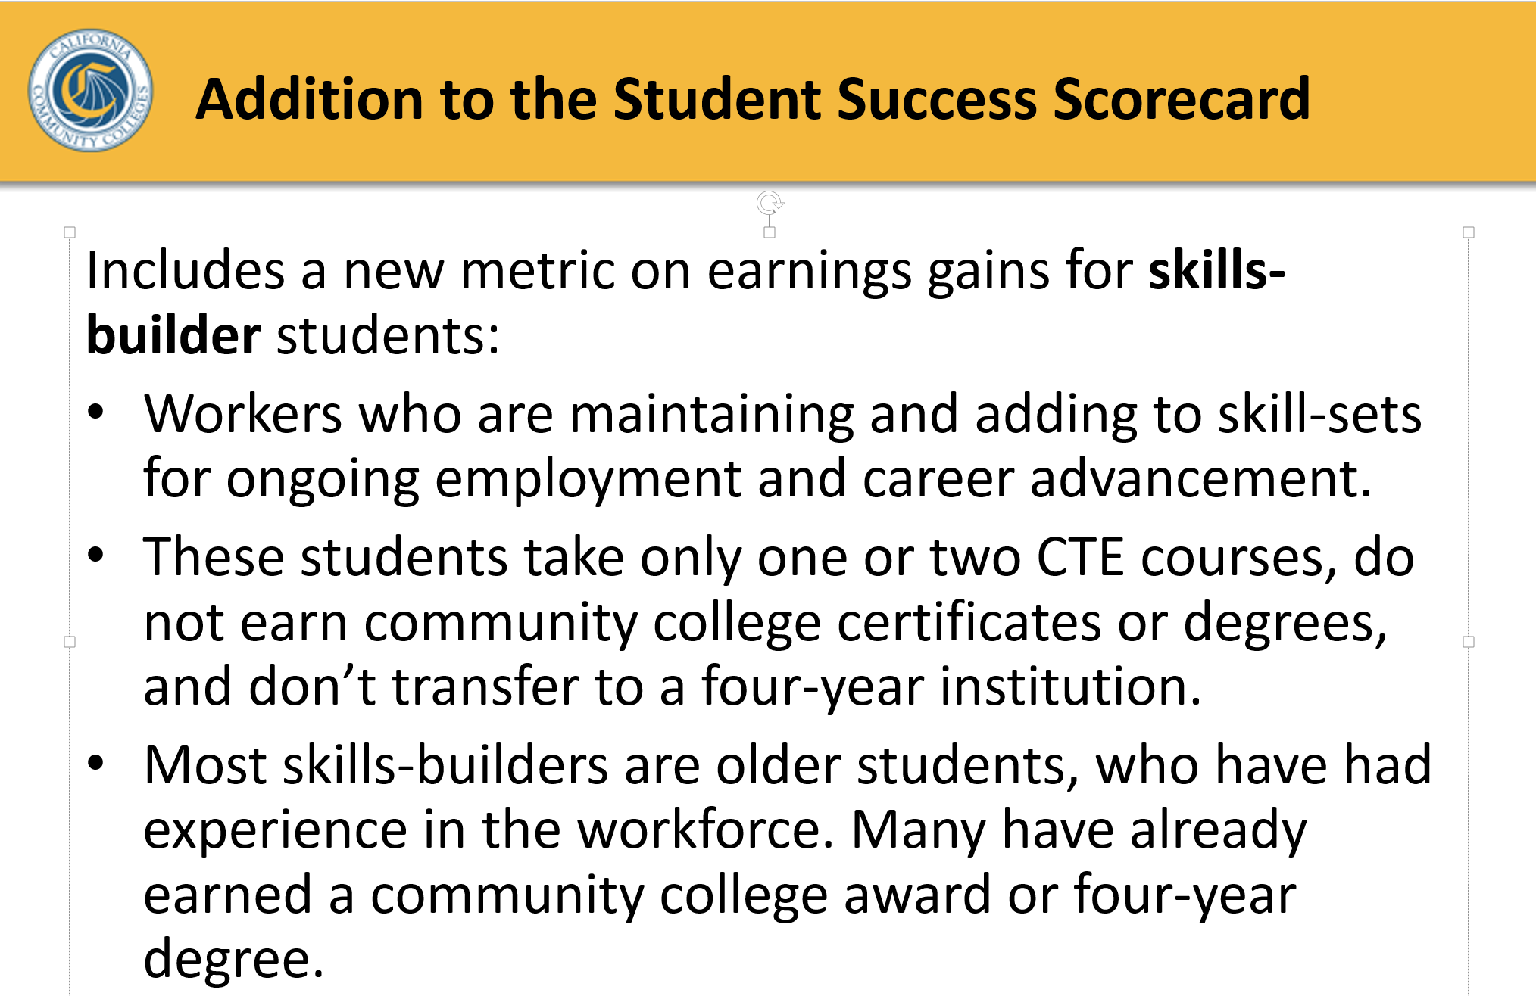

- CCSF’s ACCJC Report on Job Placement and Licensure Rates
  - http://www.ccsf.edu/en/about-city-college

For More Information:
Theresa Fleischer Rowland
Associate Vice Chancellor, Instruction
Workforce & Economic Development
O (415) 239-3301 trowland@ccsf.edu

John Carrese
Director
San Francisco Bay Center of Excellence
City College of San Francisco
(415) 452-5529 jcarrese@ccsf.edu
www.coeccc.net Forecasting High Growth/Emerging Industries and Workforce Trends
for Community Colleges; For Demand and Supply data, the password is GetLMI

Wage Tracker: College Wage Tracker & Salary Surfer
Part of the Chancellor’s Office Data Mart, Wage Tracker shows total awards and student wages three years after earning a degree or certificate. Users can specify one or multiple colleges, high-level or specific Taxonomy of Program (2 and 6 digit TOP) codes, and award types.

This report uses California Employment Development Division (EDD) Unemployment Insurance (UI) wage data.

This is the same data source that is used for the Salary Surfer, which provides state-level information of graduates’ earnings based on their program of study.

Web link: http://datamart.cccco.edu/Outcomes/College_Wage_Tracker.aspx

And http://salarysurfer.cccco.edu/SalarySurfer.aspx

When to use it:
• Writing grant applications
• Conducting program review
• Engaging in regional planning

What to use it for:
• Evaluating how well programs are training students for the workplace

CTE Outcomes Survey (CTEOS)
Conducted by Santa Rosa Junior College, the CTE Outcomes Survey (CTEOS) is a voluntary, statewide survey of students in California community college career and technical education programs, one year after they earned a credential or stopped taking courses. It collects information such as employment in field of study, attainment of a third-party credential, whether students started a business, changes in the number of hours worked, and wages before and after attending college.

Web link: http://cteos.santarosa.edu

Note: Results from the CTE Outcomes Survey are displayed on the LaunchBoard free of charge (https://www.calpassplus.org/Launchboard/CTEOS.aspx).

When to use it: • Conducting program review • Engaging in regional planning

What to use it for: • Evaluating how well programs are training students for the workplace

CTE LaunchBoard 2.0

The LaunchBoard is a web-based, user-friendly data dashboard that brings education, employment, and labor market data together to inform decision-making and planning for career and technical education (CTE) programs.

Supported by the California Community Colleges Chancellor’s Office and hosted by CalPASS Plus, the LaunchBoard is designed to foster conversations across sectors, regions, and grants by bringing together information on CTE programs in one, easy-to-access location.

For example, users can see lists of related occupations by sector or Taxonomy of Program (TOP) code in the Program Snapshot tab. This tab also provides summaries and trend information about regional enrollments, completions, and employment.

Web link: www.calpassplus.org/Launchboard/Home.aspx

When to use it:
• Developing new programs
• Designing curriculum
• Writing grant applications
• Conducting program review
• Engaging in regional planning

What to use it for:
• Assessing the types of jobs that are aligned with college programs
• Understanding the projected supply of qualified workers
• Evaluating how well programs are training students for the workplace
- And much more….

