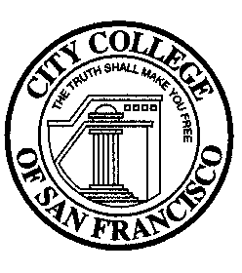
Enrollment Management Committee
1:00 pm - 3:00 pm on December 15, 2022
Zoom link: https://ccsf-edu.zoom.us/j/82426355436

DRAFT AGENDA
Members: Geisce Ly (Admin Co-Chair), Wynd Kaufmyn (Faculty Co-Chair), J Carlin, Edie Kaeuper, Monika Liu, Edgar Torres, Mitra Sapienza, Colin Hall, Dawn Mokuau, Silvia Urrutia, Heather Brandt, Lydia Jian, and Angelica Nevarez
Alternates: Cynthia Dewar, Mandy Liang, Amy Coffey, Steven Brown, and Nicole Fang
Resource Support: Lisa Cooper-Wilkins and Pam Mery
Upcoming Meetings: 1/19/23, 2/16/23, 3/16/23, 4/20/23, and 5/18/23
No. | Items | Speaker/Facilitator | Duration
1. | Welcome | Geisce Ly | 5 minutes
2. | Approve November 17th Minutes | Geisce Ly | 3 minutes
3. | Approve today’s agenda | Geisce Ly | 3 minutes
4. | Student Support Strategies Ad Hoc Committee | Lisa Cooper Wilkins | 15 minutes
5. | Data Analysis Ad Hoc Committee | Pam Mery | 5 minutes
6. | EMC Objectives for 2022-23 | Wynd Kaufmyn | 15 minutes
7. | Instructional Budget & Schedule Development | Geisce Ly | 10 minutes
8. | Multi-year enrollment management plan | Geisce Ly | 60 minutes
9. | Future Agenda Items | Geisce Ly | 3 minutes
Join from PC, Mac, Linux, iOS or Android:
Or iPhone one-tap (US Toll): +16699006833, #82426355436
Or Telephone: Dial: 669-900-6833 (US Toll) Meeting ID: 824 2635 5436

